“Angry People & Amiable Peacemakers”
Dr. Ritch Boerckel
September 23, 2012

Scriptural Foundation: 1 Samuel 25, ESV

Interestingly, Chapters 24 and 26 have to do with David resisting the urge to take revenge against King Saul. Here we see David acting in a noble and godly fashion. In the previous study we considered those chapters, but in this study David is going to give himself over to sinful anger, vengeance, and fury. We see, juxtaposed between two chapters of a godly man acting in a godly manner, but here we find a godly man acting in an ungodly fashion. This teaches us much about the battle and struggle each of us faces; we are fallen and we cannot expect yesterday’s victories to carry over to today, but we must be ready to fight the good fight of the faith by God’s grace everyday. In our text we will consider the topic of anger and peacemaking; anger in David and peacemaking in this lovely woman, Abigail.

The Death of Samuel
¹ Now Samuel died. And all Israel assembled and mourned for him, and they buried him in his house at Ramah.

David and Abigail
Then David rose and went down to the wilderness of Paran. ² And there was a man in Maon whose business was in Carmel. The man was very rich; he had three thousand sheep and a thousand goats. He was shearing his sheep in Carmel. ³ Now the name of the man was Nabal, and the name of his wife Abigail. The woman was discerning and beautiful, but the man was harsh and badly behaved; he was a Calebite. ⁴ David heard in the wilderness that Nabal was shearing his sheep. ⁵ So David sent ten young men. And David said to the young men, “Go up to Carmel, and go to Nabal and greet him in my name. ⁶ And thus you shall greet him: ‘Peace be to you, and peace be to your house, and peace be to all that you have. ⁷ I hear that you have shearers. Now your shepherds have been with us, and we did them no harm, and they missed nothing all the time they were in Carmel. ⁸ Ask your young men, and they will tell you. Therefore let my young men find favor in your eyes, for we come on a feast day. Please give whatever you have at hand to your servants and to your son David.’”
⁹ When David's young men came, they said all this to Nabal in the name of David, and then they waited.
¹⁰ And Nabal answered David's servants, “Who is David? Who is the son of Jesse? There are many servants these days who are breaking away from their masters. ¹¹ Shall I take my bread and my water and my meat that I have killed for my shearers and give it to men who come from I do not know where?” ¹² So David's young men turned away and came back and told him all this. ¹³ And David said to his men, “Every man strap on his sword!” And every man of them strapped on his sword. David also strapped on his sword. And about four hundred men went up after David, while two hundred remained with the baggage.
¹⁴ But one of the young men told Abigail, Nabal's wife, “Behold, David sent messengers out of the wilderness to greet our master, and he railed at them. ¹⁵ Yet the men were very good to us, and we suffered no harm, and we did not miss anything when we were in the fields, as long as we went with them. ¹⁶ They were a wall to us both by night and by day, all the while we were with them keeping the sheep. ¹⁷ Now therefore know this and consider what you should do, for harm is determined against our master and against all his house, and he is such a worthless man that one cannot speak to him.”
¹⁸ Then Abigail made haste and took two hundred loaves and two skins of wine and five sheep already prepared and five seahs of parched grain and a hundred clusters of raisins and two hundred cakes of figs, and laid them on donkeys. ¹⁹ And she said to her young men, “Go on before me; behold, I come after you.” But she did not tell her husband Nabal. ²⁰ And as she rode on the donkey and came down under cover of the mountain, behold, David and his men came down toward her, and she met them.

Matthew Henry is a famous Bible commentator in the latter part of the 17th Century. One day, in his older years, a street ruffian accosted him, threatening him and robbing him of his money. After this dramatic and unjust incident, Matthew Henry went home and wrote these words in his journal, “Let me be thankful, first, because he never robbed me before. Second, although he took my purse he did not take my life. Third, because, although, he took all I posses, it was not much. Fourth, because it was I who was robbed and not I who robbed.”

I wonder what I would have written in my journal if that had happened to me? Henry’s perspective on personal insult and abuse is different from the one I commonly carry. To the natural mind which is so conscious of personal rights and so aggressive toward threats to pride, this perspective seems strange and foreign. Who thinks of God in such affronts, let alone thanks God for them? I am particularly impressed by the fourth reason Matthew Henry gives for his gratitude toward God: It was I who was robbed and not I who robbed.

Henry understands it is much more joyful and beneficial to be the one who is sinned against than the one who does the sinning. The one who is sinned against retains his or her eternal treasure, the joy found in the Holy Spirit, while the one who sins forfeits it. The righteous need never to envy the wicked, yet sometimes we do. That is the story in our text of 1Samuel 25. This is a story of three characters. The first is a wicked man who acts wickedly. The second is a righteous man who allows himself to be overcome by evil and then he acts wickedly. The third is a righteous woman who acts as a minister of peace. We will consider life lessons primarily from the latter two, David and Abigail.

We will consider David losing his battle with anger and Abigail finding a way to make peace; one loses the other finds. We find the context for this study in Chapter 24. David made an agreement with Saul, at Saul’s request, after sparing Saul’s life,

^{22 b} Then Saul went home, but David and his men went up to the stronghold.

David has been hiding in the caves in the region of En Gedi, around the Dead Sea, and he moves a short distance to what is called “the stronghold”.

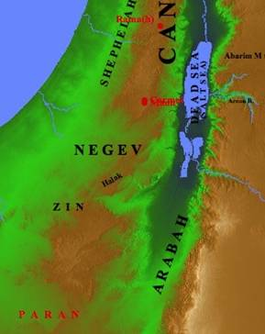

Maps help us to understand these stories are not make-believe fairy tales, that they happen to be real places, in real time, with real people. En Gedi is in the north, along the Dead Sea. This is where David has been, but he is going to move to the stronghold.



In this picture we see palm trees in the midst of rough terrain, but there are little crevasses and caves. These are cool places with water.

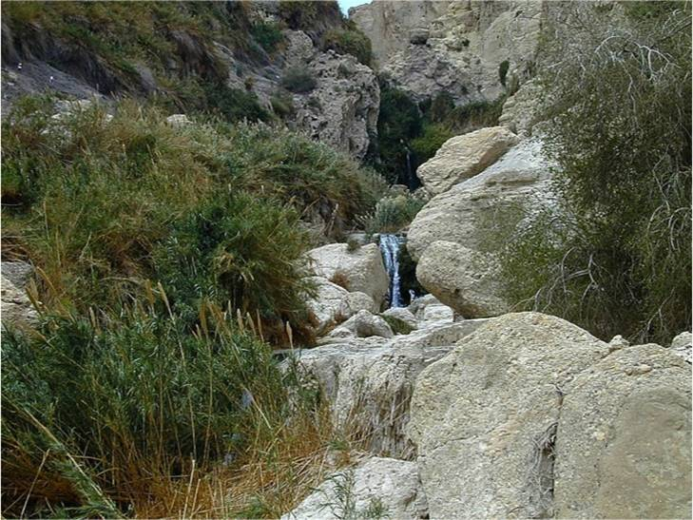

Along the Dead Sea, a short distance from En Gedi is this stronghold called Masada. There are many cliffs like this, so if it is not this one mentioned, it is likely something like this. Masada is very prominent in that region.

In our text the prophet Samuel dies. This godly man served God all of his life, from the time he was a small boy. This is a huge spiritual loss for David and the Nation. We are told,

^{1b} And all Israel assembled and mourned for him, and they buried him in his house at Ramah.

It is interesting the Nation would mourn for God’s prophet in his death while they did not listen to him very well in his life. Often times godly people are appreciated after they die

^{1b} Then David rose and went down to the wilderness of Paran.

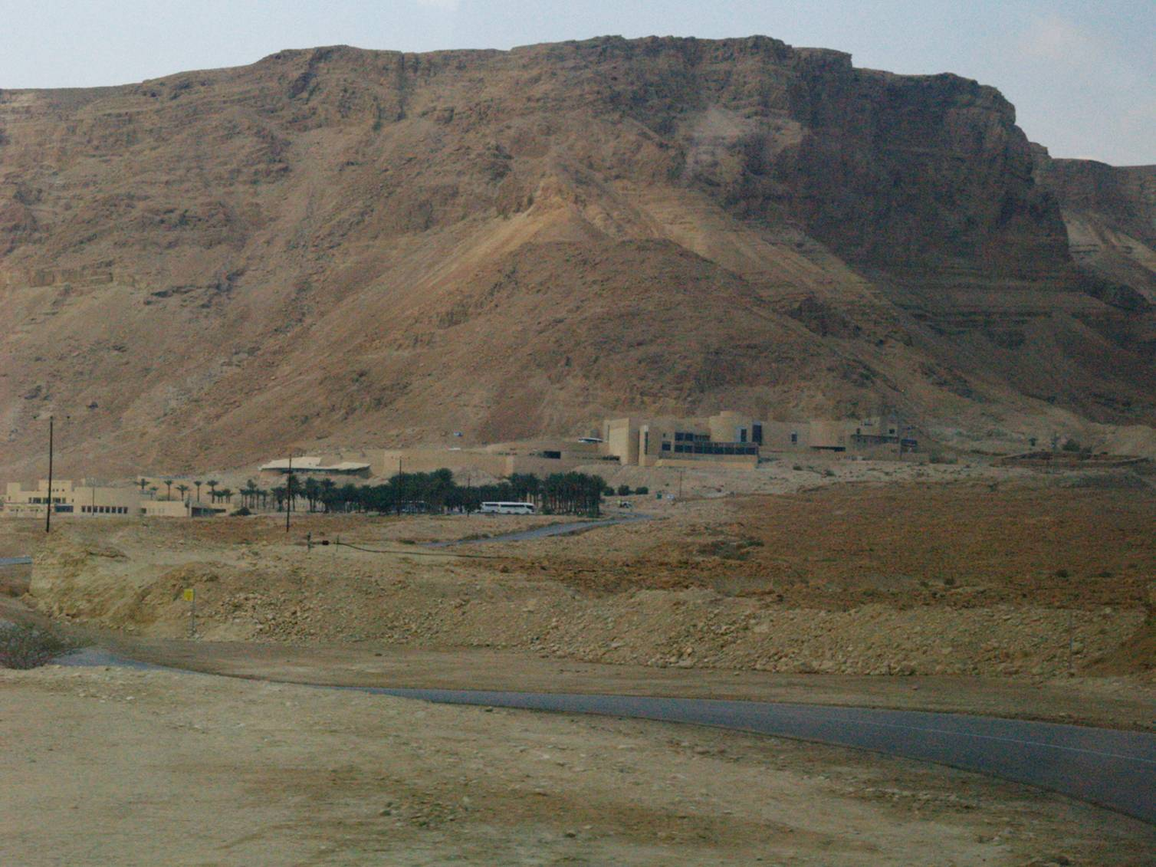

The wilderness of Paran is over one hundred miles away from the stronghold.

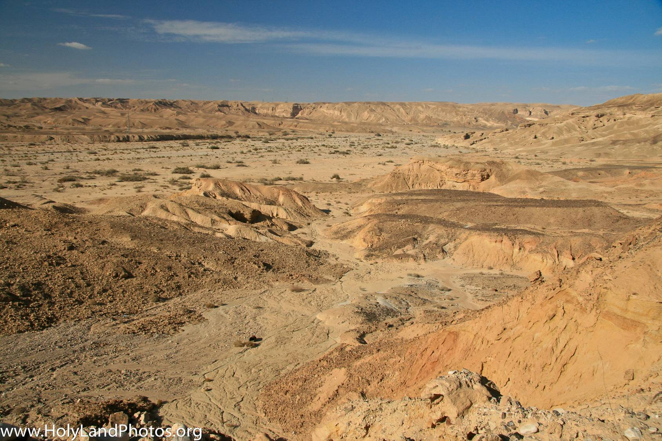

En Gedi looked dry, but this region is really dry as it receives only about two to four inches of rain per year. This is an incredible desert.

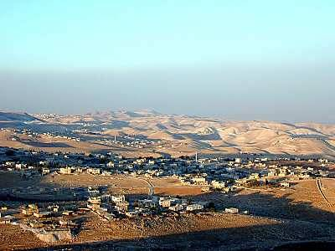

David will travel from Paran back up to Maon, where this story takes place,

² And there was a man in Maon whose business was in Carmel. The man was very rich; he had three thousand sheep and a thousand goats. He was shearing his sheep in Carmel. ³ Now the name of the man was Nabal…

Carmel is a short distance, about a mile, from Maon. Carmel is where Nabal has his sheep shearing business. As we consider Nabal, which means “fool”, let us be aware a person can be rich in a number of different ways, in friends, in talents, in opportunities, in character, in happiness, toward God, and in things. Nabal is described as “rich” but he is rich in only one of these categories, the least category, which is the last one anyone would choose, the least significant and the least joyful. He is wealthy in the goods of this world. He is rich in flocks, but not in faith or friendships. When a person is rich only in the things of this world, only in material possessions, they are actually very poor people. So it is with Nabal.

He reminds us of that rich fool Jesus speaks of in Luke 12. Before Jesus speaks of him, He makes this preface to His remarks,

¹⁵ And he said to them, “Take care, and be on your guard against all covetousness, for one's life does not consist in the abundance of his possessions.”

How we need to hear that and continue to think about that! Our very spiritual life is threatened by this deception,

¹⁶ And he told them a parable, saying, “The land of a rich man produced plentifully, ¹⁷ and he thought to himself, ‘What shall I do, for I have nowhere to store my crops?’ ¹⁸ And he said, ‘I will do this: I will tear down my barns and build larger ones, and there I will store all my grain and my goods. ¹⁹ And I will say to my soul, “Soul, you have ample goods laid up for many years; relax, eat, drink, be merry.”’

He is wealthy enough not to be concerned anymore about his life and he is ready to enjoy the good life he has dreamed of. But,

²⁰ …God said to him, ‘Fool! This night your soul is required of you, and the things you have prepared, whose will they be?’ ²¹ So is the one who lays up treasure for himself and is not rich toward God.”

Those are words we need to hear today.

It is sheep shearing time and this is a time of extravagant feasting. It is a time of harvest and a time when shepherds have more than enough to spare to share with others. This is similar to our Christmas time when there is an extra spirit of generosity in the air.

We do not know if Nabal’s parents gave him his name or if he came by it honestly by earning it. Either way, he lives up to his name in the story. He is described as being harsh and badly behaved. There is one redeeming factor in Nabal’s life, and that is he has an awesome wife, Abigail, who is “discerning and beautiful”, “both lovely and wise”.

The term beautiful is only used of two other women in the Bible: Rachael and Ester. Abigail is wise in that she understands how to live life skillfully, in business, in relationships, in righteous living, and everything she does. How sad Nabal could not appreciate what he had. Such is the nature of fools.

Husbands, if your wife is anything close to being like Abigail, make sure you communicate to her and to God what a privileged man you are. Only fools do not realize what they have when they have an Abigail.

Why did Abigail marry Nabal? It is likely, in her context, she had no choice in the matter. Her father probably agreed to the match because of Nabal’s wealth. Sadly, I look around and I discover many Abigails marry Nabals in our world and that is hard to understand. Sometimes the motivation may be financial security or emotional, but it always a foolish decision to marry a fool. Abigail likely had no say, but as you have a say, young women, marry godly men and you will save yourself from a world of sorrow. Make that your number one characteristic trait.
⁶ “And thus you shall greet him: ‘Peace be to you, and peace be to your house, and peace be to all that you have. ⁷ I hear that you have shearers. Now your shepherds have been with us, and we did them no harm, and they missed nothing all the time they were in Carmel. ⁸ Ask your young men, and they will tell you.’ Therefore let my young men find favor in your eyes, for we come on a feast day. Please give whatever you have at hand to your servants and to your son David.’”
Nabal’s sheep are in, what we call, rough country. It is wild country and there are outlaws and roaming bands. David is saying, by the virtue of his men being present, they kept Nabal’s flocks from being raided by these bands. David provided protection and it was a legitimate, incredible help, and the men in the field knew that, as they will say later in the story. They will talk with Abigail and tell her they would have had incredible trouble if David’s men had not been there. David wants to communicate he has been a great benefit and Nabal can verify the truth of the story. Notice David’s use of a term of affection.

Notice, also, how humble and reasonable the nature of David’s request is. He waited until Nabal was making money in order to ask for any benefit. He did not ask Nabal to give before the shearing time and before he had any money in his bank.

David did not want to intimidate Nabal with his own presence so he sent his men. He knows he has a reputation for power and might and he instructed his men to be kind and warm, “Peace be with your whole house”, and speak blessing upon them. He listed very carefully and exactly how he helped Nabal, that there was nothing missing, he was not robbed, he was not taken advantage of, and how they protected Nabal’s flocks from other bad characters.

He reminded Nabal of the custom common throughout the day of sharing generously during shearing time and the time of the feast. He did not make a specific demand of compensation. He left that up to Nabal’s generosity and then he waited in reply,

¹⁰ And Nabal answered David's servants, “Who is David? Who is the son of Jesse? There are many servants these days who are breaking away from their masters. ¹¹ Shall I take my bread and my water and my meat that I have killed for my shearers and give it to men who come from I do not know where?”

The surliness and childish nature of Nabal’s reply is on full display. He insults David by refusing to even recognize him. Nabal knows who David is, just like everyone in Israel knows after the incident with Goliath. In fact, if David had not slain Goliath, guess whose sheep they would be? Guess what would have happened to Nabal. He is in the dangerous country, between the Philistines and the inland of the land of Israel. He would have been one of the first to be killed and have all of his land and possessions taken by the Philistines, had they prevailed. He should have been grateful to David, but instead he insults him.

Then, he deepens the insult by pulling up the painful relationship David has with King Saul as if David had anything rebellious to do against King Saul. Nabal knows King Saul is after David and Nabal takes his “knife” and he puts it in David and twists into David’s heart. Nabal prides himself on his own possessions, “My, my, my! Everything is mine.”

Biblical generosity is not, “Let me take what is mine and share it with you.” That is not biblical generosity that is a form of generosity the world knows, but that is not our generosity. Biblical generosity is, “I am going to manage the Lord’s resource as a good steward of His possessions in order to supply the needs of other people and to bring glory to God.” That is biblical stewardship. It is, “Everything is the Lord’s”, and that is not Nabal’s perspective.

So inhospitable is Nabal one Southern Baptist preacher writes, “Nabal must not have been a southerner. Southerners know better than to treat a guest so inhospitably.”

Feel David’s hurt for a moment and think about what all is going on. Samuel just died and David is mourning the loss of this dear friend, but more than that, this spiritual counselor is still wandering through the desert. Even after sparing Saul’s life in Chapter 24, Saul has renewed his hostility. David is responsible for feeding six hundred men and there is a real possibility of starvation. We have seen the pictures of the land. David is kind and generous to Nabal. He has offered a legitimate service to Nabal which deserves legitimate compensation.

David is the next in line to be king. He has been anointed by Samuel to be the next king. But, here is the lowlife who treats David like dirt. There is great injustice served here and David is in a time of his life, I believe, where he is very vulnerable to the sin of anger.

I want you to know yourselves and be aware of the context of your life at various times because there are certain seasons in which we are particularly vulnerable to the temptation of sin, particularly sinful anger. It is important for us to prepare ourselves during those seasons. David did not prepare himself, and thus, he lost.

David looses his battle with anger and there are three disgraces to David’s anger. First, David flashes,

¹³ And David said to his men, “Every man strap on his sword!”

Notice what is missing from David’s response. There is no, “Men, let us pray about what God would have us do in response to this.” “Let us wait upon the Lord and see what the Lord does to Nabal and see how the Lord supplies our need.” “Let us search Scripture because we are confused and in dark times.” “Let us search out and talk to the high priest and seek their counsel.” I do not believe David is wrong for being angry. Nabal violated God’s principles of love and respect, but David sinned in his anger by allowing his anger to flash in impatient passion. James says,

^{1:19} Know this, my beloved brothers: let every person be quick to hear, slow to speak, slow to anger;
²⁰ for the anger of man does not produce the righteousness of God.

This indicates quick anger is never from God. If ever a time your anger flashes, understand that is not a godly response and one driven by God’s Spirit. God’s anger is never a flashing anger. Flashing anger is not a small problem, but it is huge. Flashing anger gives vent to words which dishonor Jesus, attitudes which corrupt our soul, and actions which rebel against God’s righteousness. Flashing anger should act within our soul and whenever we observe it, we should take notice of it as we take notice of a flashing red light at a railroad stop. It is flashing for a purpose, to get our attention. If we think of that flashing red light as small and insignificant, something to ignore, we will lose our lives and David nearly lost his life had it not been for God’s intervention through Abigail. He would have lost walk with God, his worship of God, his future, his influence, his reputation, and indeed his very soul. How many godly men and women participate in their own demise by giving away to flashing anger?

Proverbs say,

^{15:18} A hot-tempered man stirs up strife, but he who is slow to anger quiets contention.

^{16:32} Whoever is slow to anger is better than the mighty, and he who rules his spirit than he who takes a city.

Here is godly David being overcome by quick anger. I love that the Holy Spirit is faithful to record all the warts of godly people, because it reminds me the Bible is not about human righteousness which originates from our own will power. It is not about a righteousness working up from within which we create through discipline and diligence. Rather, the Bible is about God’s righteousness originating in Christ alone, coming down upon us as we place our faith in Jesus. That is how we find righteousness. It is never from within. What we see in these men who are godly and who have received God’s righteousness there is still a principle inside of them working and when they do not take great care to allow that flow of God’s righteousness to rest upon them, depending upon it, and receiving it by faith in Christ through the Holy Spirit, then that sin rises up. Scripture tells us all who have sinned have fallen short of God’s glory. That includes you and me as well.

The second idea we want to observe is: David rages,

^{13b} And every man of them strapped on his sword. David also strapped on his sword. And about four hundred men went up after David…

Notice the overkill on this. David has six hundred men and here is sheep-shearer Nabal who does not have a very powerful fighting force. David takes four hundred men. He thought this quickly, with such fury and with such rage.

²¹ Now David had said, “Surely in vain have I guarded all that this fellow has in the wilderness, so that nothing was missed of all that belonged to him, and he has returned me evil for good.”

Nabal is a fool, but the fool is going to make David become a fool, also. Then David says,

²² “God do so to the enemies of David and more also, if by morning I leave so much as one male of all who belong to him.”

David vows to kill every male, his sons, his servants, the whole house. His anger is not only quick, but it is intent upon evil action. It is out of control in its aggression. David has been unjustly treated, but now he gives vent and he responds in rage. He determines the is a right response over this injustice. He actually calls upon God in the midst of this. That is how justified he believes himself to be in his actions. How could a godly David justify the unrestrained murder of a man and his whole household? Anger deceives us and anger makes the most outrageous behavior to seem rational to the person being controlled by that anger.

A husband feels completely justified in raising his voice and calling his wife names because of something she has done to offend him, and he feels justified in it. It is as though he is doing something which is right. A church member feels justified in spreading gossip about another church member because the other church member did something to hurt them so badly. A teenager feels right about responding with rebellious contempt toward a parent who has been “unfair” and “untrusting”.

Anger finds some reason to justify its sinful expression. Hurt feelings love to find rationales and it will. Anger will deceive us and it will make the most ungodly actions seem godly. It will cause us to lose our Christian mind.

The last issue of David’s disgrace is: David persists. David tells his men to put on their swords. He is in the wilderness of Paran and Nabal is in Carmel. This is over one hundred miles and it will take him a few days to get there. Yet, when he gets there, he is still saying he will kill them. Do you think somewhere along the three days the Holy Spirit may have prompted David to reconsider his actions. If so, David blows right through that because he is mad and he is going to stay mad and he likes being mad. He persists in his plan to hold onto his anger and vent it.

Has that ever happened to you? The Holy Spirit prompts you to release your anger over to Him, to trust Him, and to wait upon Him, but you find yourself unwilling. In Ephesians 4, God says,

²⁶ Be angry and do not sin; do not let the sun go down on your anger, ²⁷ and give no opportunity to the devil.

We are not to persist in our anger and let it fester. It is like gangrene which will corrupt the whole body. Persisting anger is the most dangerous kind because it opens the door to Satan to worm into the soul and suck God’s love, grace, mercy, and kindness, out of our hearts.

Sometimes we may protest, “You do not understand my situation. I can see how David was not justified in his anger, but I am justified in my anger.” Quick anger is never from God. Raging anger, that which is harmful to another and responding to evil with evil, is never from God. Persisting anger, that which lasts through the day, is not from God.

One of the men goes to Abigail when they realize Nabal is beyond reasoning,

¹⁴ But one of the young men told Abigail, Nabal's wife, “Behold, David sent messengers out of the wilderness to greet our master, and he railed at them. ¹⁵ Yet the men were very good to us, and we suffered no harm, and we did not miss anything when we were in the fields, as long as we went with them. ¹⁶ They were a wall to us both by night and by day, all the while we were with them keeping the sheep. ¹⁷ Now therefore know this and consider what you should do, for harm is determined against our master and against all his house, and he is such a worthless man that one cannot speak to him.”

Abigail finds a way to make peace. Jesus, in Matthew 5, pronounces a special blessing upon peacemakers,

⁹ “Blessed are the peacemakers, for they shall be called sons of God.

We need more peacemakers in the Kingdom of God, in the church of Jesus. Peacemakers are like fire fighters of the congregation. They see a flame they did not start and they know if the flame is left unchecked it will ruin the whole. In great courage and boldness they risk their very lives to check that flame and to bring it down. Peacemakers advance with the waters of grace to put out the flames others have started, to protect the innocent, and rescue the whole. They put themselves in harms way and that is Abigail.

If we think in fleshly thoughts, we think, “Poor Abigail. She is married to this fool.” She knows he is a fool but she does not say it. He, undoubtedly, does not treat her very well. I can see how she, in her flesh, can say, “David is coming to get my husband, Nabal, who has been a big pain to me all of my life and who does not appreciate me. That must be the Lord’s will.” But, that is not Abigail. Abigail is filled with grace. She is a peacemaker and there are four graces Abigail evidences.

First, Abigail initiates,

¹⁸ Then Abigail made haste…

She acts as a peacemaker by taking initiative to reach out to David and then pursue peace with him. This requires courage and godly zeal.

It is scary stuff to get in the way of an angry warrior. I know, being a peacemaker is not for the faint of heart, but that is what peacemakers do. They risk themselves for the sake of peace. We will never become peacemakers apart from courage and a willingness to initiate peace talks when conflicts break out. Suppose you are a member of a youth group and two friends suddenly become angry with each other. They are talking gossip about each other and they is strife within the youth group because of it. If you are a peacemaker, what do you do? The peacemaker initiates and they go to each person and say, “I know you have been hurt, but I also know God wants peace in this circumstance between you and this other person. Do you desire peace from God in your relationship? How can I help you work for peace? Let us open Scripture and seek that out together. Can we get together and ask God to bring peace to this bad situation?”

Abigail made haste because she knew the fire of anger does not extinguish itself. It never does.

Secondly, Abigail invests,

¹⁸ …and took two hundred loaves and two skins of wine and five sheep already prepared and five seahs of parched grain and a hundred clusters of raisins and two hundred cakes of figs, and laid them on donkeys.

Being a peacemaker is often costly. It is easy for us to say it is not our fight and if we get involved we could lose both friends. We begin chalking up the cost it may be to us to create peace. There almost always is a real cost which is possible for us to pay. It can cost us financially, as it did Abigail. It can cost us emotionally, socially, and personally through out time and energy. Many times we say we do not have time to be a peacemaker and the people in conflict need to work that out on their own.

Third, Abigail informs. When she approaches David she does so with a hope to give David some perspective. What David lost, and what anger always does for us, anger caused him to focus on secondary causes. And it causes us to do that, also. Abigail caused a discussion on the primary cause. What is the primary cause to everything when we believe in a Sovereign God? It is God! Anger sets us off on secondary causes and we get consumed with them. But, Abigail was a peacemaker and she wanted to talk about God and His purposes in this circumstance.

What do you think God wanted to do through this? She discussed this with David and suggested he re-fix his eyes upon Him,

²³ When Abigail saw David, she hurried and got down from the donkey and fell before David on her face and bowed to the ground. ²⁴ She fell at his feet and said, “On me alone, my lord, be the guilt. Please let your servant speak in your ears, and hear the words of your servant. ²⁵ Let not my lord regard this worthless fellow, Nabal, for as his name is, so is he. Nabal is his name, and folly is with him. But I your servant did not see the young men of my lord, whom you sent. ²⁶ Now then, my lord, as the Lord lives, and as your soul lives, because the Lord has restrained you from bloodguilt and from saving with your own hand, now then let your enemies and those who seek to do evil to my lord be as Nabal.

In all of this, she comes humbly as a peacemaker. She does not attempt to force peace upon them. She is willing to take as much blame for the problem as she possibly can. She is polite in her appeal to David. She knows Nabal is wrong and a fool and she is telling David his anger directed at Nabal alone will hurt many innocent people, Abigail being one of them. Abigail is also building a theological argument and lifting David’s eyes up to God and His sovereign working. She reminds David of spiritual truths he already knows: it is the Lord who saves. In the battle with Goliath, he announced to Goliath,

⁴⁶ “This day the Lord will deliver you into my hand… ⁴⁷ and that all this assembly may know that the Lord saves not with sword and spear. For the battle is the Lord's, and he will give you into our hand.”

David had lost that perspective. What was he taking with him to win this battle? He was taking spear and sword. Abigail reminds David the Lord is restraining him so he will know and remember it is the Lord who saves and David is not his own savior.

Anger says, “Take matters into your own hands.” Faith says, “Wait upon the Lord.” Sinful anger is a form of unbelief which keeps us from trusting in God. The worst form of judgment God places upon a man or woman is when He gives us over to our own sin and our own flesh,

^{1 Peter 1:5} who by God's power are being guarded through faith for a salvation ready to be revealed in the last time.

Praise God for God’s restraining work. Have you ever noticed that in your life? You are tempted and you give yourself over to certain paths in sin and you are willful and persisting in it. Yet, you find God checking, checking, checking, restraining, restraining, restraining. Let us not presume upon God’s grace, but let us embrace it and that is Abigail’s message. We must appreciate and enjoy God’s restraining work of grace keeping us from doing that which we otherwise would do. God is making it hard, but woe to the person whom God says to, “Okay, you have pushed and pushed and pushed against My restraining hand. Go for it!” That is the worst kind of judgment, to be given over to sin which will kill us and take our very lives.

Fourth, Abigail appeals and this is the most important part of the peacemaker’s work. She does not demand peace. She does not attempt to verbally intimidate for peace. She simply makes the humble appear,

²⁷ “And now let this present that your servant has brought to my lord be given to the young men who follow my lord. ²⁸ Please forgive the trespass of your servant. For the Lord will certainly make my lord a sure house, because my lord is fighting the battles of the Lord, and evil shall not be found in you so long as you live.”

Abigail reminds David of God’s faithfulness, of God’s faithful work within him, and of her confidence in his willingness to act righteously.

²⁹ “If men rise up to pursue you and to seek your life, the life of my lord shall be bound in the bundle of the living in the care of the Lord your God. And the lives of your enemies he shall sling out as from the hollow of a sling.”

Abigail reminds David no one can harm him as long as the Lord is with him. Notice she uses the words of the story of David’s fight with Goliath, David’s best day when he was walking with the Lord. Peacemakers bring in our past experiences with the Lord to help a person recapture that vision of God Himself in our life.

³⁰ “And when the Lord has done to my lord according to all the good that he has spoken concerning you and has appointed you prince over Israel, ³¹ my lord shall have no cause of grief or pangs of conscience for having shed blood without cause or for my lord working salvation himself. And when the Lord has dealt well with my lord, then remember your servant.”

Abigail reminds David God has promised him he will be king and if he takes this action it will come back upon his kingdom. She tells David to set himself up for blessing when God fulfills His promise to him as king. David is to remember mercy in the midst of all of this. Her appeal is designed in every point to keep David’s wounded pride from being energized. She is humble and gentle with him. Yet, at every point she open David’s eyes to God’s sovereign grace working in his life and in his future.

We learn about peacemaking from Abigail. Are will willing to exercise the courage and grace to be peacemakers?

The end of the story concludes with Nabal’s death; God takes Nabal’s life and he dies the death which God, in righteousness and justice, established for Nabal. We focused much on David as to learning how one can avoid this anger and upon Abigail as to how we can learn to become peacemakers when others in the church begin to give themselves over to anger. But, let us think about Nabal. He was a fool.

What keeps us from becoming Nabal’s? What keeps us from being that fool who loves this world so much and who believes that is what life is all about? What keep us from being one who sees possessions and says, “Mine, mine, mine,” and being rich in things but who is not rich toward God. There is only one thing which rescues us from being a “Nabal” because Scripture tells us we are all born fools, darkened to life, and darkened to His light, and that is God’s sovereign grace pursuing us and opening our eyes to see there is a treasure so great and so rich the treasures of this world are not even worthy to be compared to it. That treasure is Jesus Christ Himself and the salvation Christ offers to know God and to walk with Him everyday.

The Gospel tells us about that treasure and the story of our hopelessness and the darkness of our soul to see it. We will never see that treasure apart from God’s grace. God sent His Son in love because He loved us and in order to reveal God to us, reveal the treasure, and reveal the path to know Him. He died upon the cross so our sins could be removed from us and we can have a right relationship with the Living God. By the power of God’s Holy Spirit, God announces His Gospel to us through His Word. Something happens in our soul and we awaken to see it. When we see the beauty of God we say, “I want that,” and the response we make is we repent of our sin and say, “I do not want this life which is consumed with this world and its ending in a big nothing and going nowhere.”

God is eternal God and He is the great Treasure and that is what we want for our life. If we repent of our sin and turn to Christ and say, “Christ, I believe in You as my Savior and my Lord.” I ask you, have you received the Treasure of God Himself through the Gospel of Jesus? Have you repented of your sin and said, “Yes, God, I see you and you are the greatest Treasure I can ever pursue. I believe Jesus is that Treasure. He is the path of finding you and knowing you. I trust in Him.”

This very day you can call out to God as God is working in your heart and say, “Yes, God, I want a life connected to you, the Living God. I know that life is through Jesus and I embrace Him. I rest my soul on Him.” God is willing to receive you even now and rescue you from being a Nabal and allow you to be noble all the days of your life as you walk with Him.

Romans 3:23

